# 

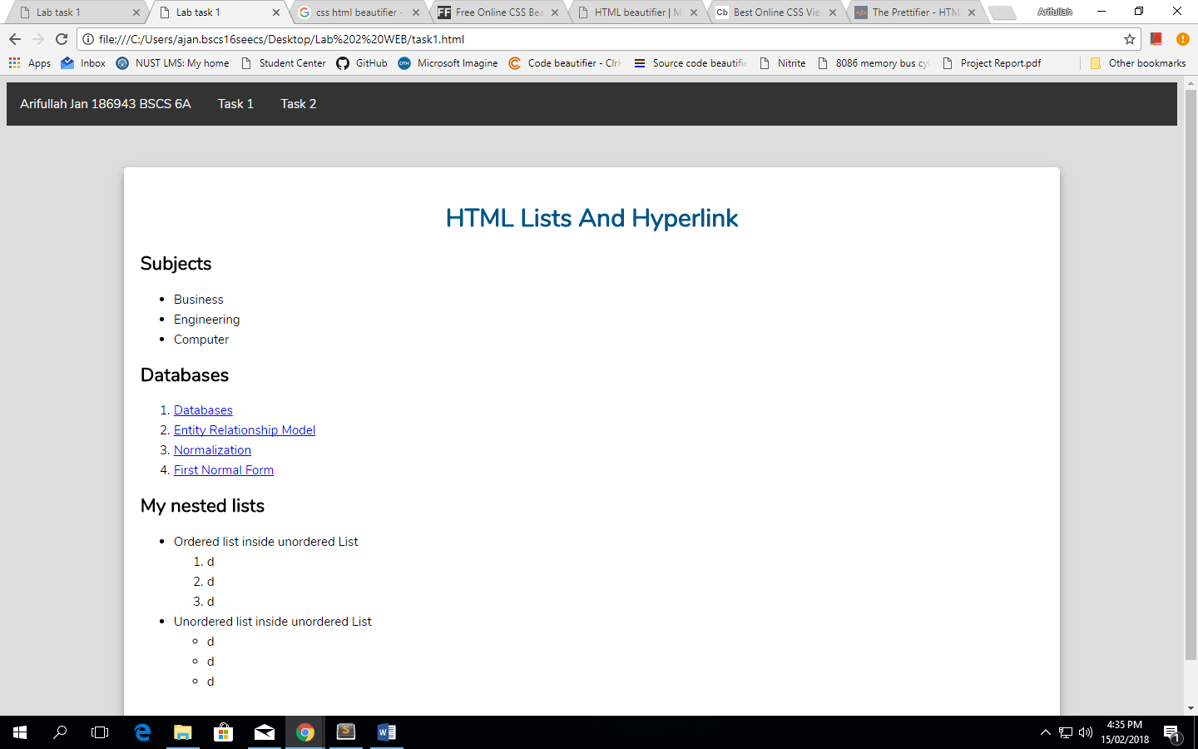

# 

# CSS

@charset "utf-8";

@import url('https://fonts.googleapis.com/css?family=Nunito');

body {

background: #ddd;

font: 15px/24px Nunito, Arial, sans-serif;

}

h1 {

text-align: center;

padding: 10px;

color: #058;

}

.outwrap {

width: 80%;

margin: 50px auto;

background: #fff;

border-radius: 5px;

box-shadow: 0 4px 8px 0 rgba(0, 0, 0, 0.2), 0 6px 20px 0 rgba(0, 0, 0, 0.19);

}

.inwrap {

padding: 20px 20px;

min-height: 600px;

height: auto;

}

.header {

background-color: #333;

overflow: hidden;

}

.header a,

p {

float: left;

color: #f2f2f2;

text-align: center;

padding: 14px 16px;

text-decoration: none;

}

.header a:hover {

background-color: #ddd;

color: black;

}

#table-report-card {

width: 100%;

border-collapse: collapse;

}

#table-report-card td,

th {

text-align: center;

padding: 0 8px;

border: 1px solid #AAA;

}

# TASK 1

<!DOCTYPE html>

<html>

<head>

<title>Lab task 1</title>

<link rel="stylesheet" type="text/css" href="my-style.css" />

</head>

<body>

<div class="header">

<a>Arifullah Jan 186943 BSCS 6A</a>

<a href="task1.html">Task 1</a>

<a href="task2.html">Task 2</a>

</div>

<div class="outwrap">

<div class="inwrap">

<h1 class="title">HTML Lists And Hyperlink</h1>

<h2>Subjects</h2>

<ul class="unordered-list">

<li>Business</li>

<li>Engineering</li>

<li>Computer</li>

</ul>

<h2>Databases</h2>

<ol id="subtopics">

<li><a href="/352509/databases">Databases</a> </li>

<li><a href="/186749/entity-relationship-model">Entity Relationship Model</a> </li>

<li><a href="/730645/normalization">Normalization</a> </li>

<li><a href="/468972/first-normal-form">First Normal Form</a> </li>

</ol>

<h2>My nested lists</h2>

<ul class="unordered-list">

<li>Ordered list inside unordered List

<ol>

<li>d</li>

<li>d</li>

<li>d</li>

</ol> </li>

<li>Unordered list inside unordered List

<ul>

<li>d</li>

<li>d</li>

<li>d</li>

</ul> </li>

</ul>

</div>

</div>

</body>

</html>

# Task 2

<!DOCTYPE html>

<html>

<head>

<title>Lab task 2</title>

<link rel="stylesheet" type="text/css" href="my-style.css" />

</head>

<body>

<div class="header">

<a>Arifullah Jan 186943 BSCS 6A</a>

<a href="task1.html">Task 1</a>

<a href="task2.html">Task 2</a>

</div>

<div class="outwrap">

<div class="inwrap">

<h1 class="title">My Table</h1>

<table id="table-report-card">

<tbody>

<tr>

<th colspan="4">Result Card</th>

</tr>

<tr>

<th>Course</th>

<th>Code</th>

<th>Credit Hours</th>

<th>Grade</th>

</tr>

<tr>

<td>Database Systems</td>

<td>220</td>

<td>4.00</td>

<td>B</td>

</tr>

<tr>

<td>Comp Organisation &amp; Ass Lang</td>

<td>235</td>

<td>4.00</td>

<td>B+</td>

</tr>

<tr>

<td>Data Strucs &amp; Algorithms</td>

<td>250</td>

<td>4.00</td>

<td>A</td>

</tr>

<tr>

<td>Technical &amp; Business Writing</td>

<td>212</td>

<td>2.00</td>

<td>B+</td>

</tr>

<tr>

<td>Linear Algebra</td>

<td>222</td>

<td>3.00</td>

<td>B+</td>

</tr>

</tbody>

</table>

</div>

</div>

</body>

</html>